Website Corrections

- Make the landing page (Hero Section) for wealth only addressing Doctors & HNIs.
- Tag Line: Clarity. Discipline. Compounding.
- Strategic Wealth Management for Doctors & High-Income Professionals
At Miracle Wealth, we design structured, goal-driven strategies focused on long-term growth and financial independence. Through disciplined investing, intelligent asset allocation, and retirement-first planning, your wealth grows with purpose — not speculation.
From portfolio strategy to liquidity planning and integrated risk protection, every solution is tailored to your life stage and long-term vision.
Build with clarity. Grow with discipline. Compound with confidence.
- Schedule a strategy call: How to add google calander?

- Add CTA: Schedule a Strategy Call
- Under services section, add services in following order;
- Wealth Management for Doctors & HNIs
- Retirement Planning
- Loan Against Mutual Funds
- Maternity Health Insurance
- Comprehensive Health Insurance
- Term Insurance
- Claim Settlement Assistance: If your health or life insurance claim is rejected, we manage the case end-to-end — from document review and insurer coordination to formal escalation with regulatory and legal authorities when necessary. We stand with you until justice is served.

- Add call booking appointment feature. With name ‘book a call’.
- Domain Expertise: Specialised in strategic wealth planning, asset allocation, and long-term compounding frameworks — strengthened by structured risk management.
- How We Build Your Wealth (Heading)
The Wealth Vital Signs Framework (Sub-Heading)
- Diagnose: Deep dive into your current financial health, liabilities, and aspirations.
- Prescribe: Align money ﬂows with life goals and protect risks with the right cover.
- Cure: Execute goal-based investments, add opportunistic value calls.
- Review: Review progress, rebalance portfolio, and keep finances healthy.
- Adding below information for your reference to make the front end of website more doctor centric. See what can be implemented without making the website lengthy;
- Doctors’ biggest money pain points:
- Time starvation, Lack of professional guidance & trust, Surgical & legal risk exposure, No crystal-clear roadmap, Poor asset allocation, Poor investment planning
- What outcome do I deliver?
- Clarity & Structure: Turning lumpy cashflows and scattered savings into a clear, goal-linked financial plan.
- Smart Allocation – Right mix of asset allocation, optimized for kids’ education, hospital dreams & a peaceful retirement.
- Confidence & Control – Assurance that their money is being managed professionally without them needing to worry or market noise.
- Future Awareness – Showing them the exact corpus required to achieve milestones and the income they need to sustain it.
- Risk Protection – Guarding them against medical liability, income disruptions, and family security gaps.
- Opportunistic Value Calls – Using my 'Research Analyst' edge, I identify undervalued opportunities for bold lump-sum investments—helping generate long-term alpha and accelerate goal achievement.

- Overall Bio Format:
- As a Wealth Manager with half a decade of experience, an MBA in Finance, and Certified in Equity Research, we work with doctors & high-income professionals, who excel in their domain but feel stuck managing their money. Time starvation, unclear roadmap, and poor asset allocation often leave them without a solid financial plan, costing them significant wealth they could otherwise have built.
- Through our proprietary ‘Wealth Vital Signs Framework,’ we help diagnose financial pain points, prescribe strategies aligned with goals like children’s education, early retirement, hospital set-up, and transform their portfolios into a balance of steady growth and bold opportunities—so their money works as hard as they do.
- Our approach is grounded in clarity, trust, and long-term consistency. Clients value how we simplify financial decisions, shield them from risks, and grow wealth strategically.
- Our mission: Let doctors serve patients while I ensure their money is strategically managed.

- Website should go with ‘www.miraclewealth.in’ & should not show privacy warning while opening.
- Pls check if we can add one review section for doctors on main page & another review section for insurance page (i.e when someone visits insurance section under services section, should see different reviews related to insurance).
- Reviews for doctors:
- Dr. Tejas, New Delhi: I never thought a 45 mins session could bring such clarity. For the first time, may money feels working harder than me. Just clarity-planning-Swapnil's hand holding & execution. Complete game changer!
- Dr. Mihir, Mumbai: I’ve met many professionals, but Swapnil speaks a doctor’s language. He is so calm, respectful & intelligent. Investing never felt so easy. Every doctor must try him out at least once!
- Dr. Priya, Jaipur: For years, I thought I was ‘investing.’ Turns out, I was only saving. The difference Swapnil showed me changed everything. Hats off to his clarity.
- Dr. Karan, Bengaluru: As doctors, we are trained to diagnose problems — but I realised I had never properly diagnosed my finances. Swapnil’s structured approach brought clarity I was missing for years. Calm, analytical and extremely patient. I finally feel financially organised.
- Dr. Ritu: What impressed me most was not just his knowledge, but the discipline he brings to planning. No random tips, no chasing trends — just structured thinking. For the first time, my investments feel aligned with my long-term goals.
- Dr. Anirudh, Hyderabad: Between hospital duties and family life, I never had time to understand portfolio structure. Swapnil simplified everything in one session. Clear roadmap, clear execution, and zero confusion. Exactly what a busy doctor needs.

- Reviews for insurance:
- Kindly check if these can be taken from google business reviews directly. Link

- Under the insurance section, you can also add details given below;
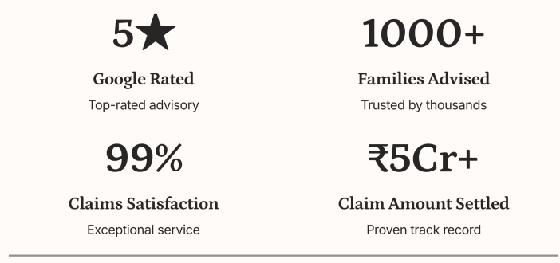

- Add section ‘Meet Our Founder’
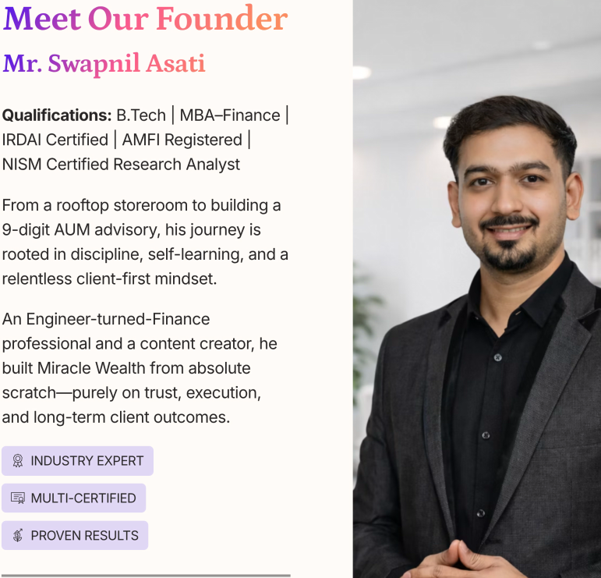

- Remove dhurandhar reel. Its off-topic. Was published for broad audience reach.
- My social media profiles, for your ready reference;
- Instagram: Link
- LinkedIn: Link
- YouTube: Link
- Google Business Profile: Link

- Add privacy policy: Link
- Instead of naming the section as ‘Insights & Updates’, rename it to ‘The Learning Centre’.
- Instead of showing only one tab of ‘Visit Instagram’, also attach ‘Visit Youtube’ tab. Link of my youtube channel
- Where can I publish blogs?
- ‘Ready to Secure Your Future?, change this heading to ‘Your Next Life Changing Step’
- Sub-heading: Book your 1:1 ‘Wealth Diagnosis Call’ with call booking button next to it.
- Kindly add mutual funds logo under the ‘Our Partners’ tab at the bottom of website on the main mutual funds / wealth page. Refer this website for visuals.
- Add insurance logos on insurance page under the ‘Our Partners’ tab at the bottom of insurance page.
- Abolish section 'Independent Financial Guidance' completely & make a new section just above the ‘What people say section’ with name ‘Real Stories, Real Results’. Present it as live case study of Dr. Poonam from Nagpur with below information;


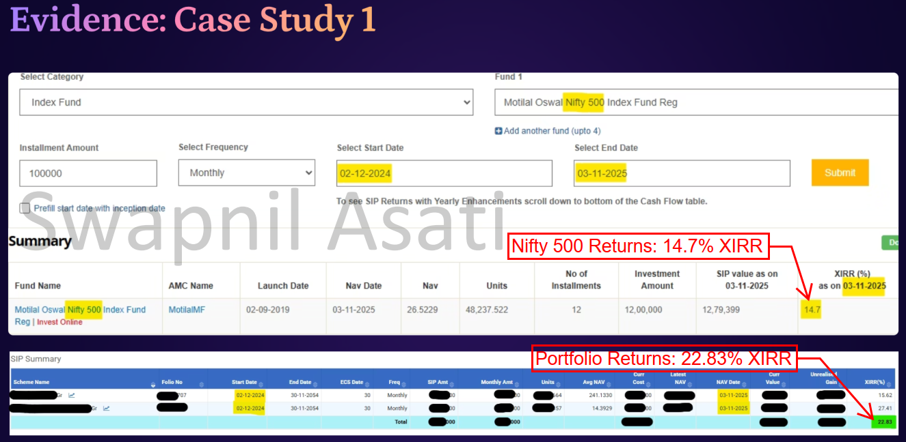
This section will add real value to doctors.

- Remove this line ‘Financial planning support, distribution services, and disciplined long-term execution tailored to your life goals.’ Mentioned at the bottom of the page – Enlarge the logo so that should be sufficiently visible – Instead of placing contact no. & ‘schedule a call’ horizontally, place them one above another just beside the logo enlarged.
- Email: miraclewealth.in@gmail.com
- Location: Ensaara Metropark, Pipla-Kharsoli Road, Pipla, Nagpur, Maharashtra, India – 440034
- Modify the line mentioned at the bottom of the page to ‘We are not a SEBI-registered investment advisor. We facilitate mutual funds (as per AMFI guidelines) & insurance distribution services (as per IRDAI guidelines). Investments in mutual funds are subject to market risks, please read all scheme related documents carefully before investing.
- Do below corrections;
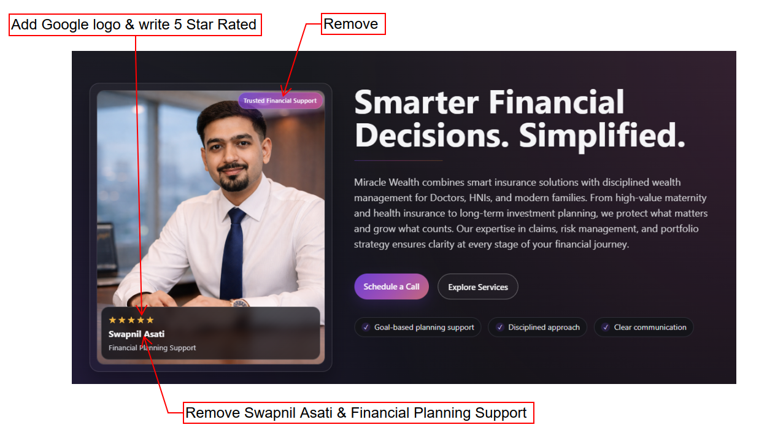
- Kindly add below details under ‘Who We Are’ section


- About Miracle Wealth:
- We closely work with Doctors & high income professionals to structure their investment planning, practical risk conversations, portfolio alignment & bring real world results.
- How we work with you?
- First Point- 1:1 Consultation – To understand you, your finances, profiling your risk & what value addition we can make.
- Rest 3 points are good to be kept as it is.

- Under about section - ‘Ready to Secure Your Future?, change this heading to ‘Your Next Life Changing Step’
- Sub-heading: Book your 1:1 ‘Wealth Diagnosis Call’ with call booking button next to it.

- Under Services, change the heading to ‘Long-Term Compounding With Protection-Led Solutions’
- Under services – services, the line should be written as a single line ‘Thoughtfully structured solutions that protect your present, strengthen long-term discipline, and support meaningful financial progress.’
- Office Hrs: Monday – Saturday: 10 am to 6 pm
- Add ‘City’ in enquiry form.
- Add ‘Others’ in interested service under enquiry form.
- Follow the same sequence under ‘Interested service’ as mentioned below;
- Wealth Management for Doctors & HNIs
- Retirement Planning
- Loan Against Mutual Funds
- Maternity Health Insurance
- Comprehensive Health Insurance
- Term Insurance
- Claim Settlement Assistance
- Where would the enquiry go if someone fill-in the enquiry form?
- When clicking ‘Schedule a Call’, its going on enquiry page, not on call booking calander.

